**I590: Data Visualization**

**Finals Proposal**

**Real Time Visualization of Bloomington Transit**

**Group Members**

Ganesh Nagarajan; gnagraj@indiana.edu

Sanjana Pukalay; spukalay@indiana.edu

Parmeet Singh Ahluwalia; pahluwal@iu.edu

**Abstract**

Bloomington Transit accounts for most ridership of public transit system in bloomington. Whilst, its double maps service offers just a basic location tracking of the busses, riders don’t get a chance to see real-time statistics of the system. Many a times, multiple busses service a single route, however it is difficult to track them in the current application. Other analytical functions like # of stops served, bus speeds etc are hidden from the customer. We attempt to develop an analytics dashboard, containing interactive elements of summarization, gauge visualizations and an map interface to interact with the real-time data.

**Introduction**

Visualizing map data is one of the oldest forms of data visualization techniques.Our project is primarily inspired from Double Maps application, available at <https://bloomington.doublemap.com/map/>. Doublemap provides an interactive map with real-time bus tracking along the designated bus routes. However it does not offer real time analytics, for the end user. We hope to develop an analytics dashboard, including an interactive map to visualize and summarise this data.

**Background and Related Work:**

One of the most successful transit visualization is MTBA visualization system, where the map provides an aggregated view of bus speeds, split into three categories, Red <10 mph, Yellow 10 to 30 mph, Green > 30 mph. Another version of very successful real time speed tracking systems is from Google maps, where the traffic intensity is described by the color overlay.

Fig 1: MTBA Bus Speed Visualization Screenshot

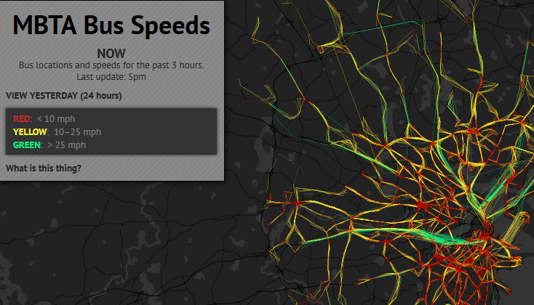

Fig 2 : Google Traffic for the Bloomington Area

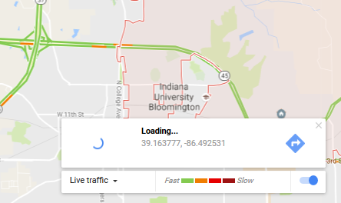

Maps data has been usually a separate isolated area in analytics. Usual data visualization methods like line charts, pie charts, gauges, have been rarely used in visualizing data along with maps.

**Research Questions**

Along with interactive maps visualization, could we add more details to the view?

* # of routes running in the system
* # of busses running in the system
* Cumulative of stops served
* Mean time between stops
* Minimum and Maximum bus speeds real time

**References**

[1]<https://bloomington.doublemap.com/map/>

[2]<https://www.codeply.com/render/KrUO8QpyXP>

[3]<http://bostonography.com/bus/>

[4]<http://bl.ocks.org/msqr/3202712>